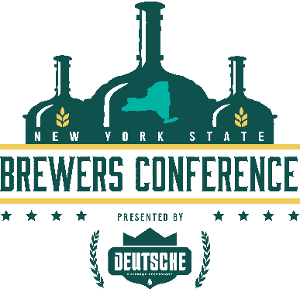
NEW YORK STATE CRAFT BREWERS CONFERENCE SPONSOR TERMS
The terms hereunder are applicable to the Sponsoring Entity (“NYSCBC Sponsor”). Sponsorship positions associated with the NYSCBC shall be paid in full prior to the event and are nonrefundable. Accordingly, the NYSCBC Sponsor shall:
Be solely responsible for all material it may seek to offer to attendees, visitors, or guests.
Insure and provide any reasonable verification that it is fully licensed, insured or permitted (to the extent necessary) to offer any such service, product, or expert advice in connection with any such product, presentation, demonstration, or material offered to attendees, visitors, or guests.
Consult with NYSCBC staff before any marketing or promotional material is presented or offered to attendees, visitors, or guests.
Refrain from expressing any representation express or implied that it is an agent of the NYSBA or NYSCBC and that it has the authority to bind or obligate the NYSBA or NYSCBC in any capacity.
Comply with any termination notice or notice to quit the NYSCBC venue in the event of any non-payment of sponsor fees, failure to honor payment of fees or willful violation of the terms hereunder.
Not enter into any assignment of any of the rights or privileges hereunder without the express written agreement of the NYSBA or NYSCBC.
Indemnify and insure the NYSBA and NYSCBC, in the event NYSCBC Sponsor shall become a party to any claim, demand or penalty or becomes a party to any suit or other judicial or administrative proceeding by reason of any act or omission of the NYSCBC Sponsor, or those persons for whom the NYSCBC Sponsor is responsible and shall further indemnify and hold the NYSBA and NYSCBC, its members, directors, officers, employees and agents harmless against all judgments, settlements, penalties, costs and expenses, including attorney’s fees, court costs and other expenses of litigation as a result of NYSCBC Sponsor’s actions.
Agree that the terms and conditions here shall be governed by and construed in accordance with the laws of or applicable to the State of New York and shall submit to the jurisdiction of the courts thereof within the county where the offices of the NYSBA are located.

